**PROJECT REPORT**

**ON**

**USED CARS PRICE PREDICTION AND**

**ANALYSIS PROJECT**



**Submitted by:**

MR. HARSH RAJ GUPTA

**FLIPROBO SME:**

Mr. Mohd Kashif

**ACKNOWLEDGMENT**

I would like to express my special gratitude to “Flip Robo” team, who has given me this opportunity to deal with a beautiful dataset and it has helped me to improve my analyzation skills. And I want to express my huge gratitude to Mr. Mohd Kashif (SME Flip Robo), he is the person who has helped me to get out of all the difficulties I faced while doing the project.

A huge thanks to “Data trained” who are the reason behind my Internship at Fliprobo. Last but not least my parents who have been my backbone in every step of my life.

References use in this project:

1. SCIKIT Learn Library Documentation
2. Blogs from towardsdatascience, Analytics Vidya, Medium
3. Andrew Ng Notes on Machine Learning (GitHub)
4. Data Science Projects with Python Second Edition by Packt
5. Hands on Machine learning with scikit learn and tensor flow by Aurelien Geron
6. Pudaruth, S. (2014). Predicting the price of used cars using machine learning techniques. Int. J. Inf. Comput. Technol, 4(7), 753-764 – [1]
7. Agencija za statistiku BiH. (n.d.), retrieved from: http://www.bhas.ba . [accessed July 18, 2018.] – [2]
8. Monburinon, Nitis, Prajak Chertchom, Thongchai Kaewkiriya, Suwat Rungpheung, Sabir Buya, and Pitchayakit Boonpou. "Prediction of prices for used car by using regression models." In 2018 5th International Conference on Business and Industrial Research (ICBIR), pp. 115-119. IEEE, 2018. – [3]
9. Gegic, Enis, Becir Isakovic, Dino Keco, Zerina Masetic, and Jasmin Kevric. "Car price prediction using machine learning techniques." TEM Journal 8, no. 1 (2019): 113. – [4]
10. Noor, Kanwal, and Sadaqat Jan. "Vehicle price prediction system using machine learning techniques." International Journal of Computer Applications 167, no. 9 (2017): 27-31. – [5] 3 Project Report on Used car prediction using Machine Learning Techniques
11. Kuiper, S. 2008. “Introduction to Multiple Regression: How Much Is Your Car Worth?”, Journal of Statistics Education, 16(3). – [6]
12. Minitab Express Support. Interpret all statistics and graphs for Multiple Regression: http://support.minitab.com/en-us/minitabexpress/1/help-andhow-to/modelingstatistics/regression /how to/multiple regression/interpretthe-results/all statistics and-graphs /
13. Gongqi, S., Yansong, W., & Qiang, Z. (2011, January). New Model for Residual Value Prediction of the Used Car Based on BP Neural Network and Nonlinear Curve Fit. In Measuring Technology and Mechatronics Automation (ICMTMA),

2011 Third International Conference on (Vol. 2, pp. 682-685). IEEE

**Chap 1. Introduction**

## 1.1 Business Problem Framing

The price of a new car in the industry is fixed by the manufacturer with some additional costs incurred by the Government in the form of taxes. So, customers buying a new car can be assured of the money they invest to be worthy. But, due to the increased prices of new cars and the financial incapability of the customers to buy them, Used Car sales are on a global increase. With the covid 19 impact in the market, we have seen lot of changes in the car market. Now some cars are in demand hence making them costly and some are not in demand hence cheaper.

Therefore, there is an urgent need for a Used Car Price Prediction system which effectively determines the worthiness of the car using a variety of features. Existing System includes a process where a seller decides a price randomly and buyer has no idea about the car and its value in the present-day scenario. o. In fact, seller also has no idea about the car’s existing value or the price he should be selling the car at. To overcome this problem, we have developed a model which will be highly effective to predict the actual price/cost of a car rather than a cost/ price range of a car.

## 1.2 Conceptual Background of the Domain Problem

Determining whether the listed price of a used car is a challenging task, due to the many factors that drive a used vehicle’s price on the market. The focus of this project is developing machine learning models that can accurately predict the price of a used car based on its features, in order to make informed purchases.

Accurate car price prediction involves expert knowledge, because price usually depends on many distinctive features and factors. Typically, most significant ones are brand and model, age, horsepower and mileage. The fuel type used in the car as well as fuel consumption per mile highly affect price of a car due to a frequent change in the price of a fuel. Different features like exterior color, door number, type of transmission, dimensions, safety, air condition, interior, whether it has navigation or not will also influence the car price. In this project, we applied different methods and techniques in order to achieve higher precision of the used car price prediction. Regression Algorithms are used because they provide us with continuous value as an output and not a categorized value because of which it will be possible to predict the actual price a car rather than the price range of a car. The data associated with the investigation was very large because there are thousands of used cars and each car’s data comprises of values of many features. Both data gathering and analysis are complex. Used cars data scrape from www. cardheko.com which is a well-known online platform for reselling used and new cars in India. Features like car’s model, make, seating capacity, color, mileage, engine capacity, brakes, Transmission type, Maximum power, Gearbox type, power steering, engine type, turbocharger, supercharger and price were included.

## 1.3 Review of Literature

Pudaruth [1] applied various machine learning algorithms, namely: k-nearest neighbors, multiple linear regression analysis, decision trees and naïve bayes for car price prediction in Mauritius. The dataset used to create a prediction model was collected manually from local newspapers in period less than one month, as time can have a noticeable impact on price of the car. He studied the following attributes: brand, model, cubic capacity, mileage in kilometer’s, production year, exterior color, transmission type and price. However, the author found out that Naive Bayes and Decision Tree were unable to predict and classify numeric values. Additionally, limited number of dataset instances could not give high classification performances, i.e., accuracies less than 70%. As per information that was gotten from the Agency for Statistics of BiH, 921.456 vehicles were registered in 2014 from which 84% of them are cars for personal usage [2]. This number is increased by 2.7% since 2013 and it is likely that this trend will continue, and the number of cars will increase in future. This adds additional significance to the problem of the car price prediction.

Nitis Monburinon et al. [3] proposed a prediction of Prices for Used Car by Using Regression Models. In this paper, the authors selected the data from the German ecommerce site. The main goal of this work is to find a suitable predictive model to predict the used cars price. They used different machine learning techniques for comparison and used the mean absolute error (MAE) as the metric. They proposed that their model with gradient boosted regression has a lower error with MAE value 0.28 and this gives the higher performance where linear regression has the MAE value 0.55, random forest with MAE value 0.35.

Enis Gegic et al. [4] proposed Car Price Prediction using Machine Learning Techniques. In this paper, they proposed an ensemble model by collecting different types of machine learning techniques like Support Vector Machine, Random Forest and Artificial neural network. They collected the data from the web portal www.autopijaca.ba and build this model to predict the price of used cars in Herzegovina and Bosnia. The accuracy of their model is 87%.

Kanwal Noor and Sadaqat Jan [5] proposed Vehicle Price Prediction System using Machine Learning Techniques. In this paper, they proposed a model to predict the price of the cars through multiple linear regression method. They selected the most influencing feature and removed the rest by performing feature selection technique. The Proposed model achieved the prediction precision of about 98%.

Kuiper [6] used this model to predict price of 2005 General Motor (GM) cars. The price prediction of cars does not require any special knowledge so the data available online is enough to predict prices like the data available on www.pakwheels.com. Kuiper [6] did the same i.e. car price prediction and introduced variable selection techniques which helped in finding which International Journal of Computer Applications (0975 – 8887) Volume 167 – No.9, June 2017 28 variables are more relevant for inclusion in model.

Normally, a value greater than 2 for standardized residuals is considered large. Since raw residual have no capability to detect outlier, therefore, Standardized residuals are considered a better measure for such detection [7].

Gonggie [8] proposed a model that is built using ANN (Artificial Neural Networks) for the price prediction of a used car. He considered several attributes: miles passed, estimated car life and brand. The proposed model was built so it could deal with nonlinear relations in data which was not the case with previous models that were utilizing the simple linear regression techniques. The nonlinear model was able to predict prices of cars with better precision than other linear models.

## 1.4 Motivation for the Problem Undertaken

The project was the first provided to me by Flip Robo Technologies as a part of the internship programme. The exposure to real world data and the opportunity to deploy my skillset in solving a real time problem has been the primary motivation.

Data needed for this project is require to scrap from internet and work over it. Deciding whether a used car is worth the posted price when you see listings online can be difficult. The focus of this project is developing machine learning models that can accurately predict the price of a used car based on its features, in order to make informed purchases. The model developed in this study may help online web services that tells a used car’s market value.

**Chap 2 Analytical Problem Framing**

# 1. Mathematical / Analytical Modelling of the Problem

Whenever we employ any ML algorithm, statistical models or feature preprocessing in background lot of mathematical framework work. In this project we have done lot of data pre-processing & ML model building. Different ML algorithm used in this project has its own mathematical background, for which you can refer Scikit documentation [1].

# 2. Data Sources and their formats

Data is collected from cardheko.com using selenium and saved in xlsx file.

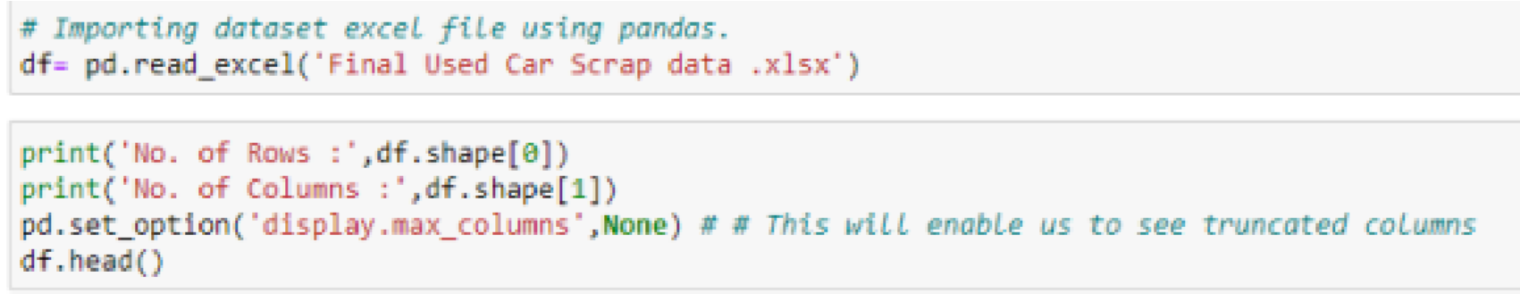

Data Scrap for 10011 cars and 19 features scrap form website. So this dataset

contain 10011 rows with 19 columns.

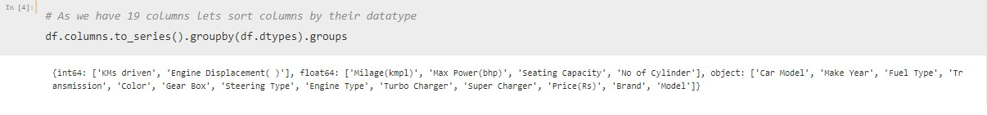

# 3. Data Pre-processing

The dataset is large and it may contain some data error. In order to reach clean, error free data some preprocessing is done on data. First task is to finding error in data or data entry correction. Second task is to convert datatypes in appropriate datatypes. Third one is to perform feature engineering on ‘make year’ to extract car age. Different data error found in data as followed:

* KMs Driven involved numeric value with object datatypes and Value are in format like 2,36,000 KMs. Here comma (‘ , ’) is removed from data and converted into numeric datatypes.

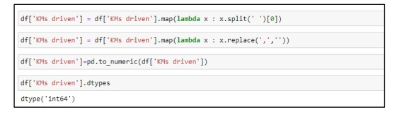

* Some of data in ‘Engine Displacement (CC)’ comes with CC notation attached to value, for example, 1497 CC. So, CC is strip away and subsequently feature converted into numeric datatype.

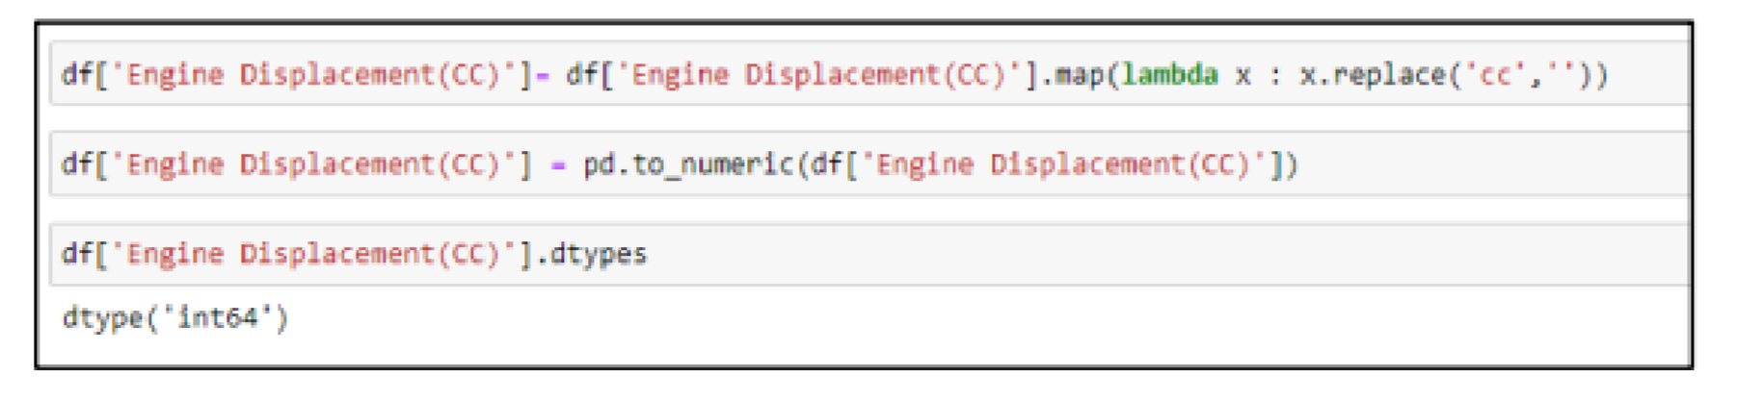

* Feature Milage contain dash ( - ) and some of values in unit of km/kg or km/hr which need to converted into standard unit kmpl. This conversion in proper unit is done and finally milage datatypes is converted into numeric datatypes.

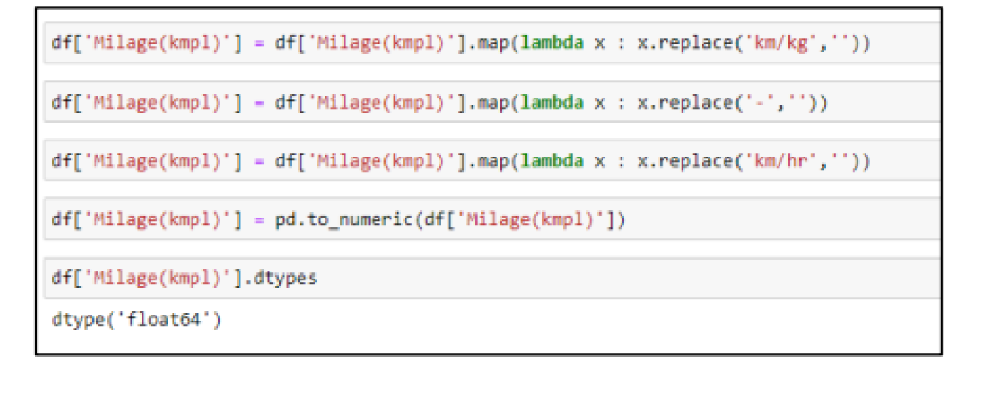

* Max Power contain serval error like presence of null, dash (-), some values with unit like PS. These errors are resolved and converted into numeric datatypes.

* In price column some entry comes in term of lakh and Cr along with numeric value (for example, 32.15 lakh*) resulting into object datatype. The conversion into appropriate numeric value requires for such entries which resolved using following piece of code.

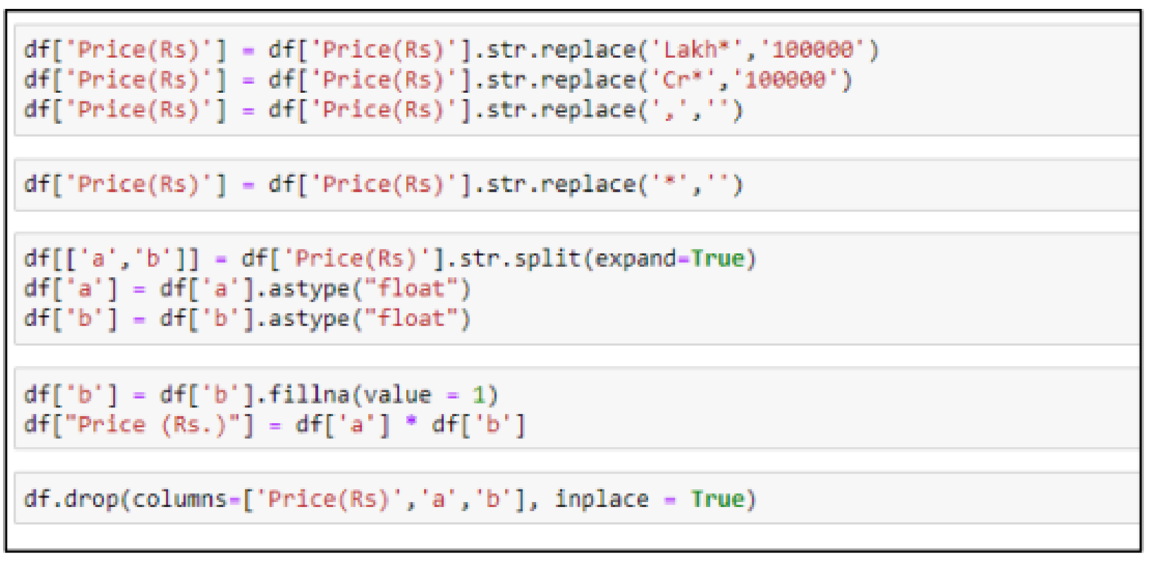

Small feature engineering performs on make year to extract how old car is since first sold out by manufacturer?

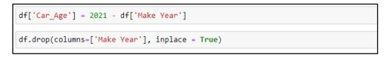

The car model name we extracted from website contain both car brand and its variant.

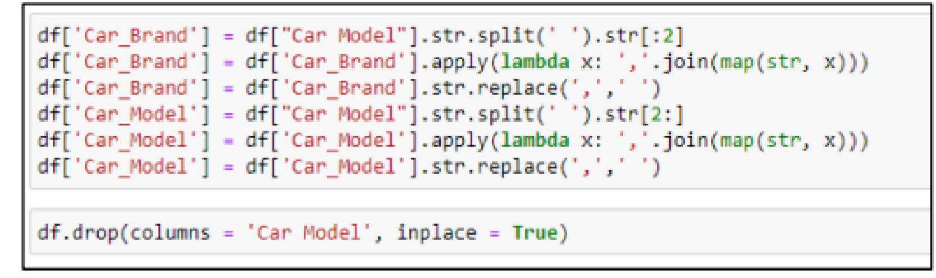

Some feature engineering performs to extract these additional features out of original car model feature using following piece of code.

Final datatypes of all feature after converting them into appropriate datatypes is shown in figure below:

In next phase of data pre-processing involves data integrity check to identify presence of duplicates, whitespaces, null value:

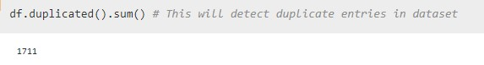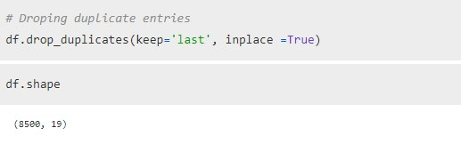

Around 1711 duplicate entry exist in dataset and eventually these duplicate entries are drop out.

We can see subcategory ‘No’ comes in two different names in value_counts of Supercharger and we also see intended correction is made in subcategory values with replace command. Similar kind of correction perform on following feature:

* Turbo Charger
* Front Brake Type
* Rear Brake Type
* Steering Type
* Gearbox

Next phase of data pre-processing is handling missing values

Many features contain missing value. Categorical value can be imputation done with mode of categories.

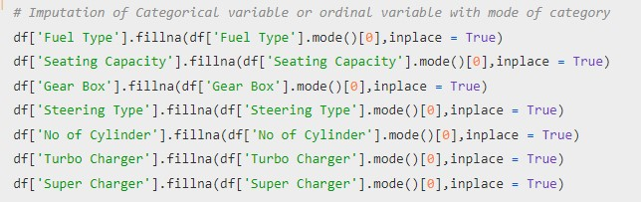

Numerical value can be imputed with mean or median depending on sensitive to outliers. For example, in this project imputation of missing value can be done after examine boxplot for outliers & distribution using distplot.

Similar kind of imputation is done for remaining feature after examining boxplot & distribution as follow:

* Imputing Max Power with Median as median is less sensitive to outliers.
* Due presence of outliers missing values impute with median.
* Imputing length with mean as almost no outliers present.

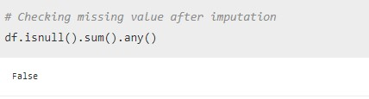

**Label Encoding of categorical data:**

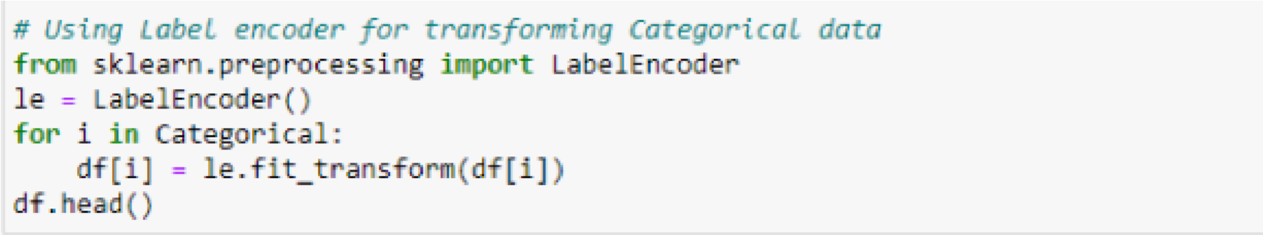

**Categorical feature are transform using label encoding**

#### 4. Data Inputs- Logic- Output Relationships

To gain more insight about relationship between input & output heatmap of correlation and bar plot of correlation of label with independents features is plotted.

We can see most of feature are either poorly or moderately correlated with

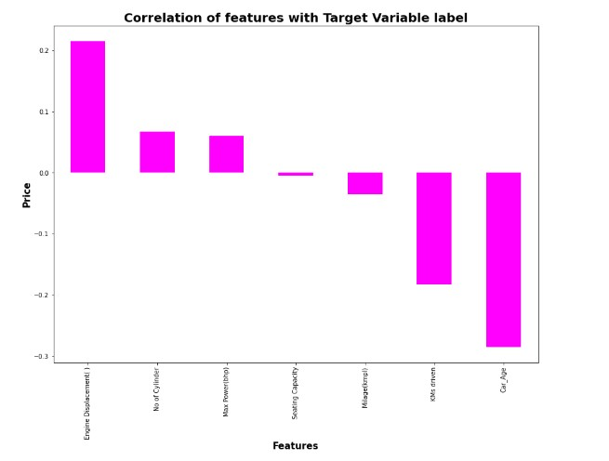

target variable Price.

### 5. Hardware & Software Requirements with

### Tool Used

1. Hardware Used -
   1. Processor — Intel i7 processor with 2.4GHZ
   2. RAM — 4 GB
   3. GPU — 2GB N Series Graphics card

1. Software utilised -

1.Anaconda – Jupyter Notebook

* 1. Selenium - Webscraping
  2. Google Colab – for Hyper parameter tuning

1. Libraries Used –

1. Different libraries used for web scraping as follow:

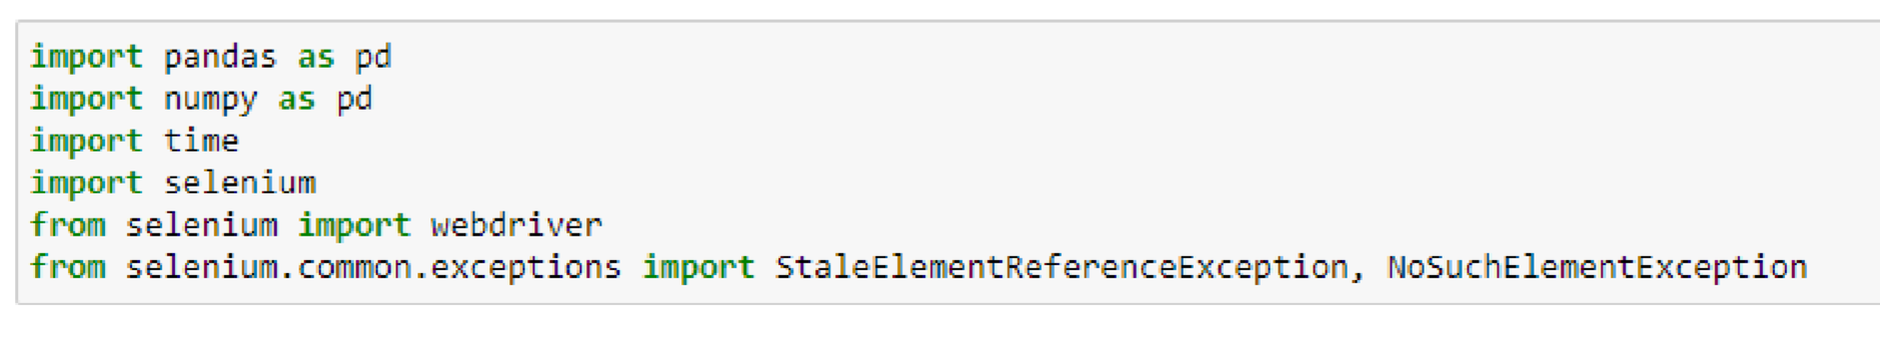

1. Different libraries are used while building ML model and

Visualization of data.

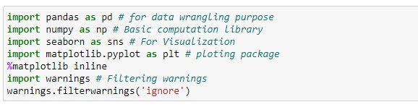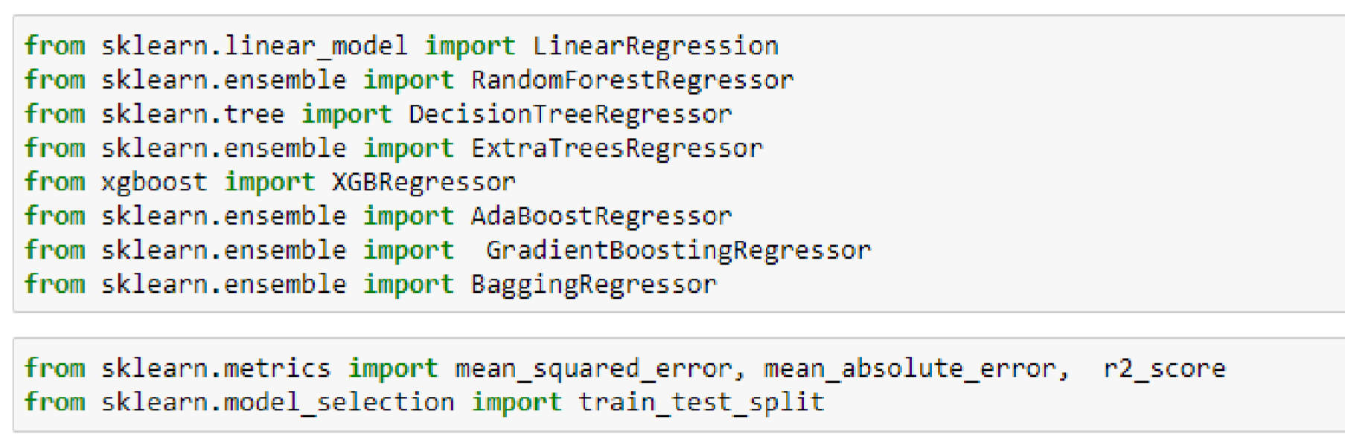

**Chap. 3 Models Development &**

**Evaluation**

### 1. IDENTIFICATION OF POSSIBLE PROBLEMSOLVING APPROACHES (METHODS)

First part of problem solving is to scrap data from cardheko.com website which we already done. Second part of problem building machine learning model to predict price of used car. This become regression problem which can be solved using different regression-based algorithm. Out of them best model can be tuned using hyper parameter tuning to enhance R2 score of best models. At end we will save our final model using joblib.

### 2. Testing of Identified Approaches (Algorithms)

Phase 1 Web Scraping Strategy employed in this project as follow:

1. Selenium will be used for web scraping data from cardheko.com 2. In first part Scraping URL of Used car for different location in India.

1. Storing Scrap URL in excel file.
2. Selecting car feature to be scrap from website.
3. In second part Scraping data from individual URL in excel file.
4. Exporting final data in Excel file.

The different regression algorithm used in this project to build ML model are as below:

* Random Forest Regressor
* Decision Tree Regressor
* XGB Regressor
* Gradient Boosting Regressor
* Bagging Regressor

### 3. KEY METRICS FOR SUCCESS IN SOLVING PROBLEM UNDER CONSIDERATION

Following metrics used for evaluation:

1. Mean absolute error which gives magnitude of difference between the prediction of an observation and the true value of that observation.
2. Root mean square error is one of the most commonly used measures for evaluating the quality of predictions.
3. R2 score which tells us how accurate our model predict result, is going to important evaluation criteria along with Cross validation score.

### 4. RUN AND EVALUATE SELECTED MODELS

Random forest Regressor gives R2 score of 83.70 %.

**1.**

**Random Forest Regressor**

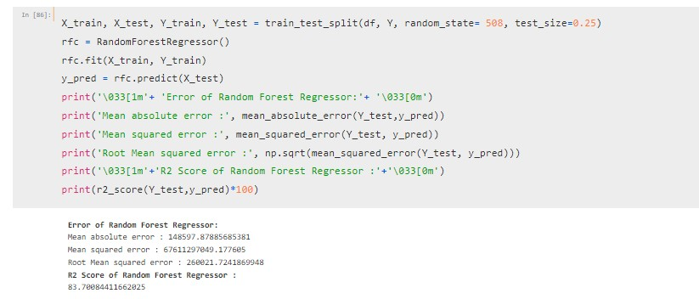

k-6 fold cross validation perform which gives CV score as 75.99 %.

Finally difference between R2 and CV Score 7.71 %.

**2.**

**XGB Regressor**

**3.**

**Decision Tree Regressor**

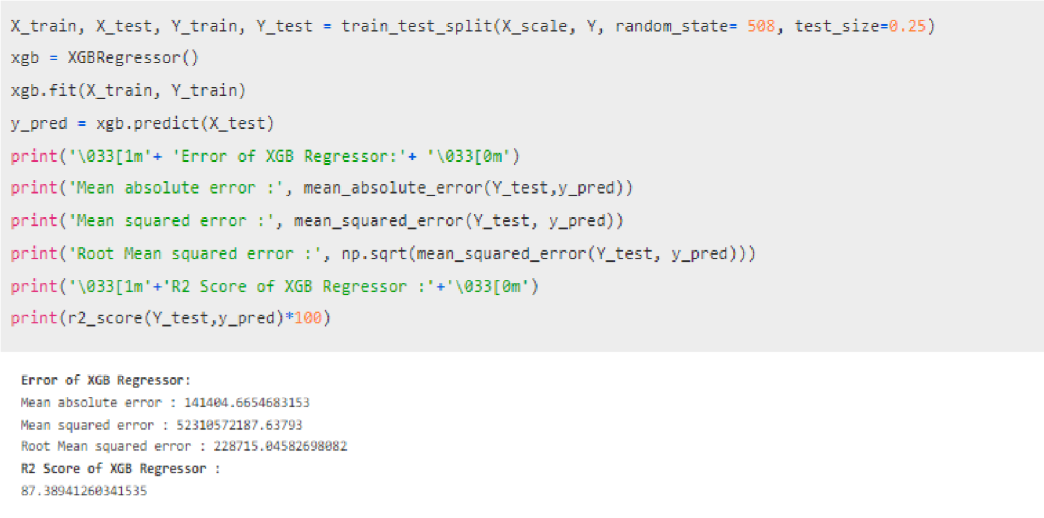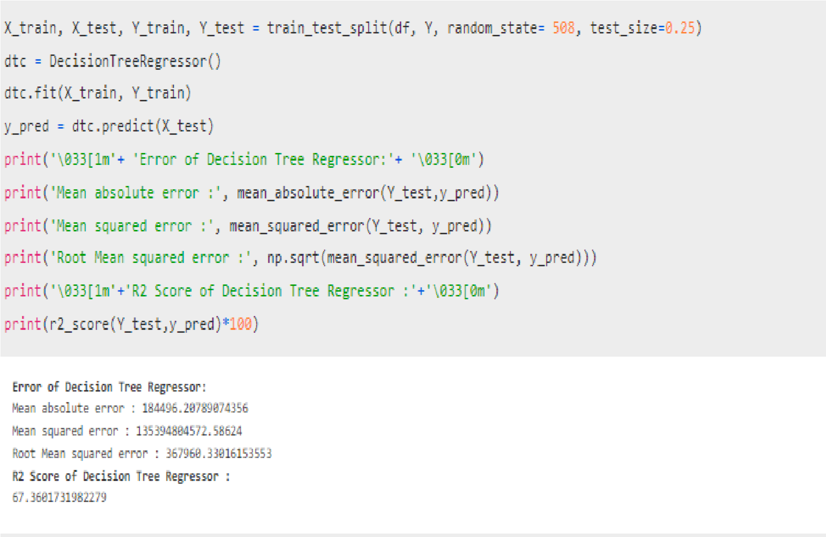

than 60%, So we will select model which has less difference

**4.**

**Extra Tree**

**Regressor**

All model is giving us R2 score & Cross validation Score more

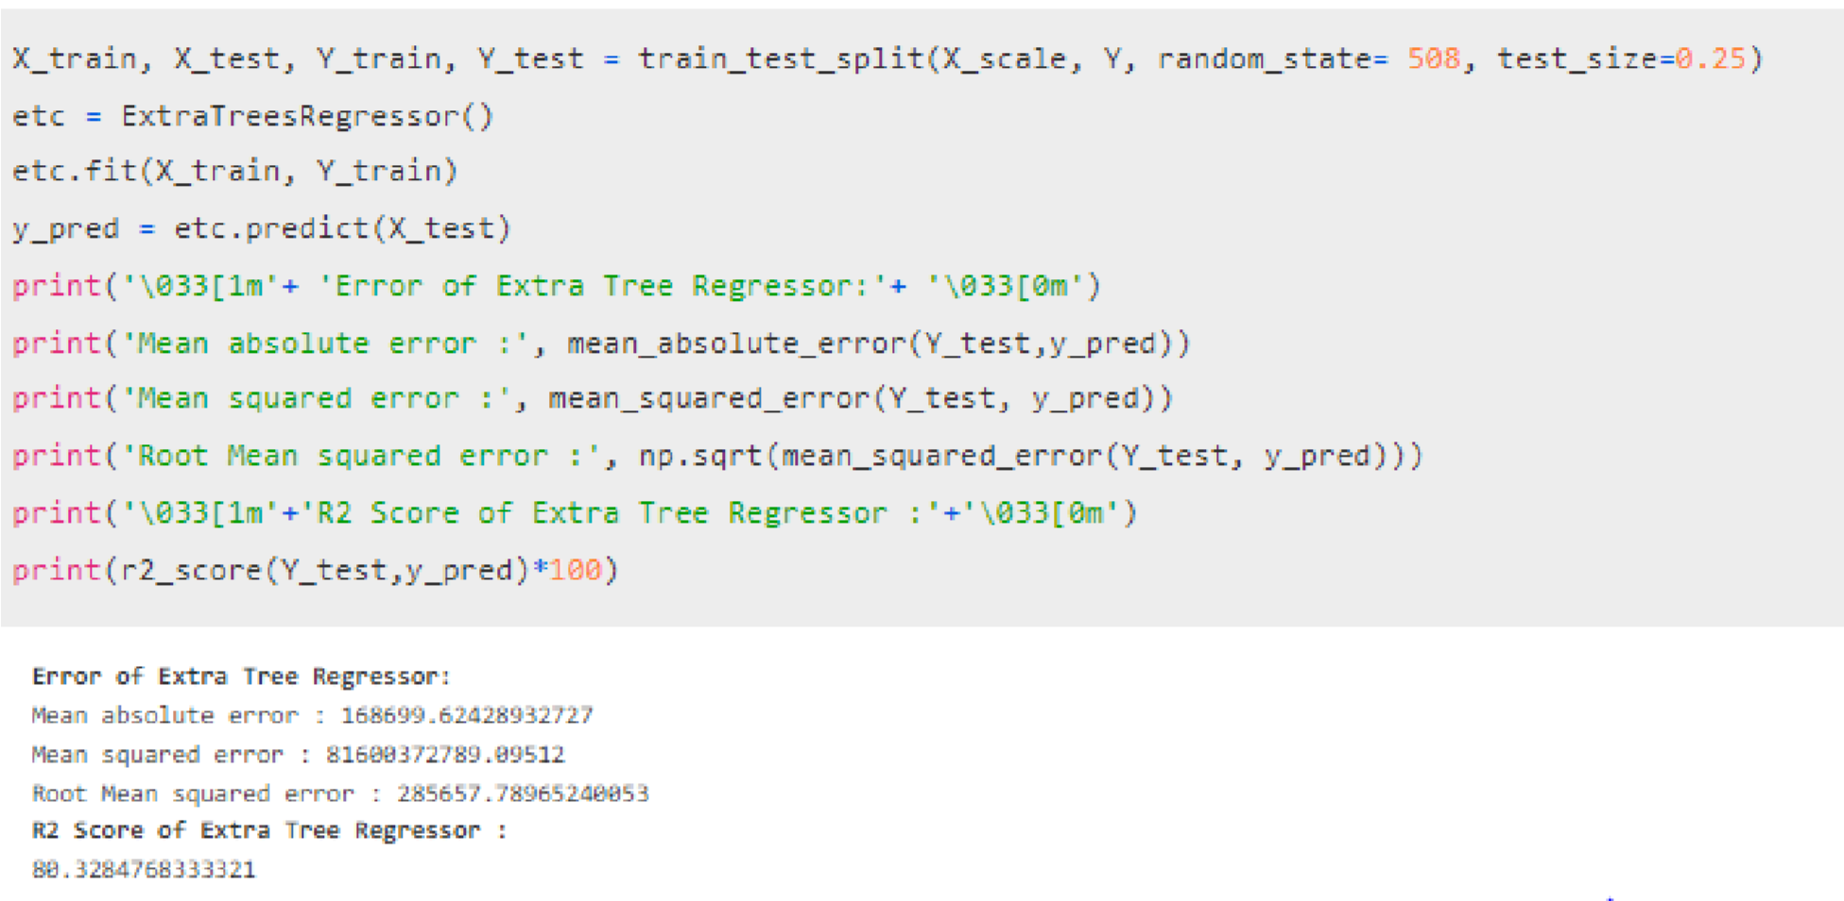

|  |
| --- |
| between these scores. On Basis of difference between R2 Score |

and Cross Validation Score XGB Regressor is selected as best

model with 87.38% r2_score. We will perform Hyper Parameter

tuning over this model

W

e got best parameter

s

for

final model

Final model is saved using joblib library.

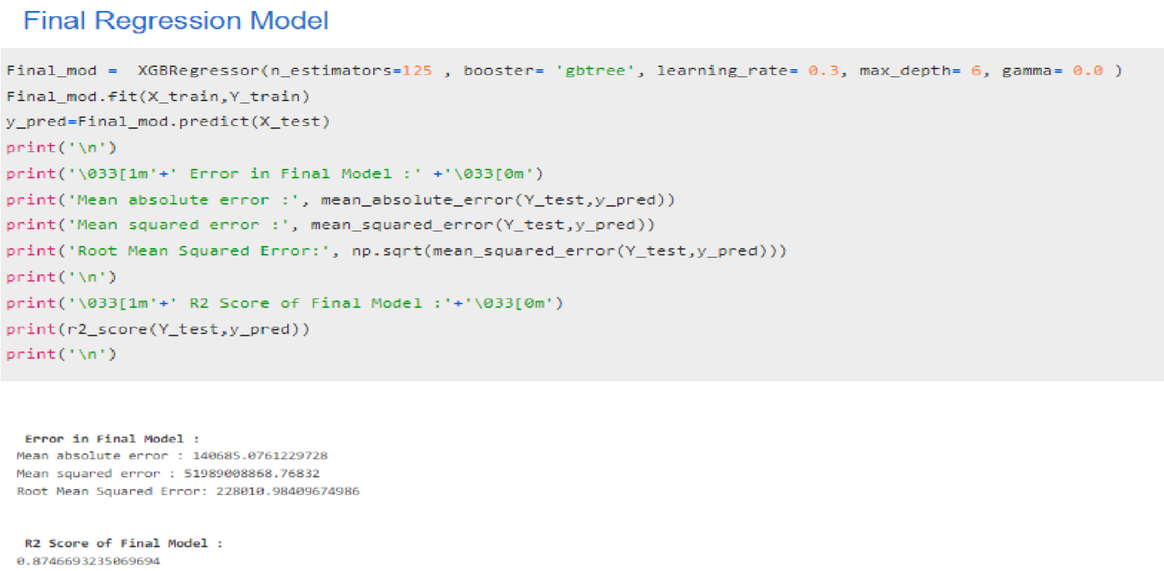

### 5. VISUALIZATIONS

Let see key result from EDA, start with fuel type.

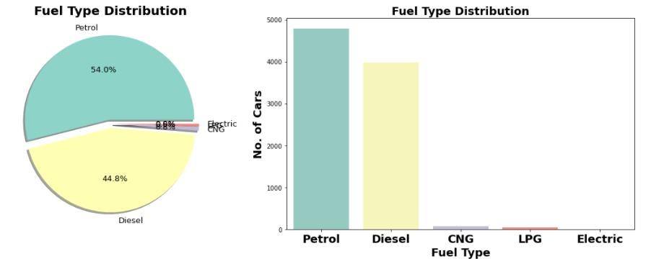

* Most of car are Petrol operated followed by Diesel. This may be due to low prices of Petrol car compare to diesel car.
* Very small segment of electric car and also price is quite high compare to petrol based.

CNG based car are Cheapest compare to others

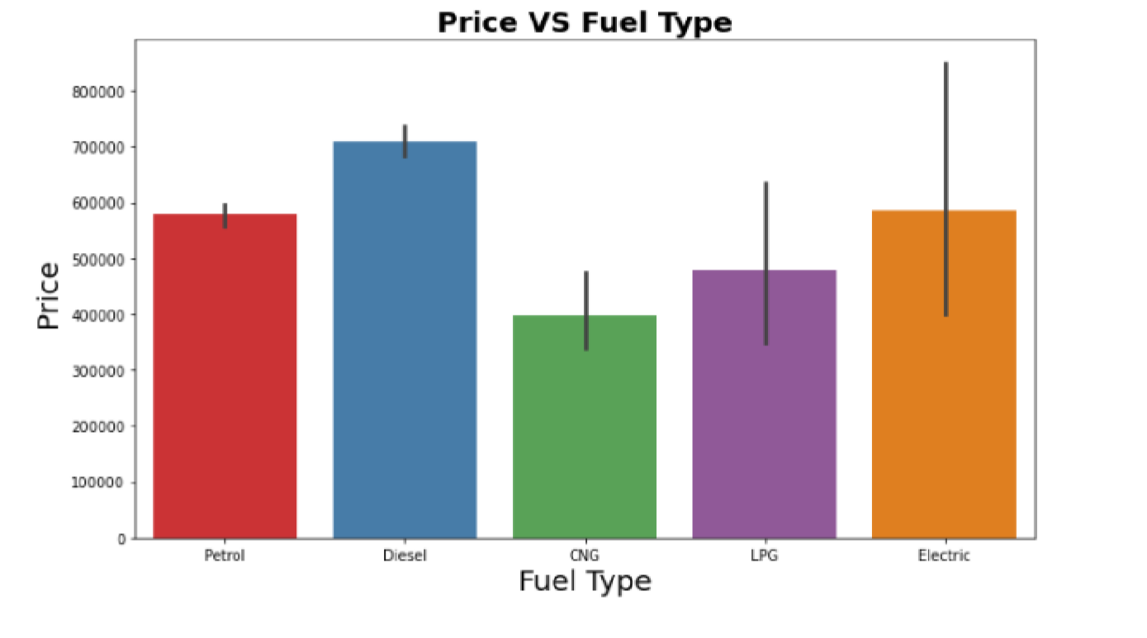

➢

Price Vs Steering Type

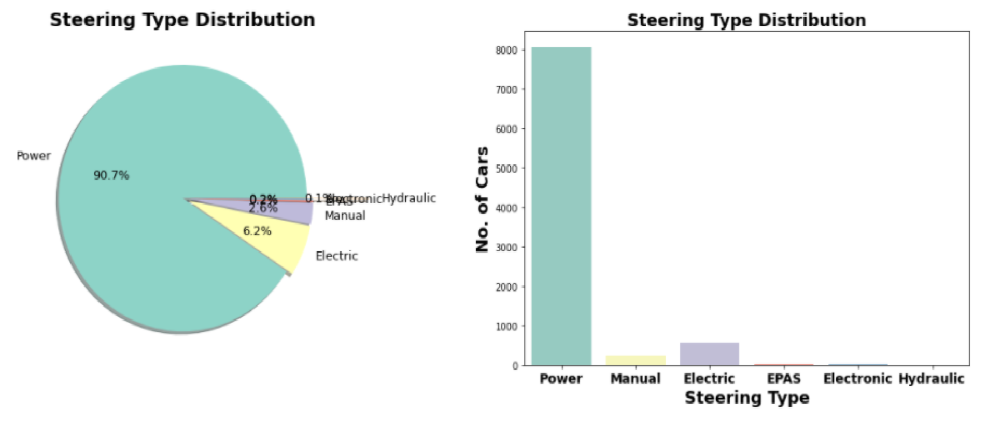

More than 90 % of car users prefer Power steering compares to others.

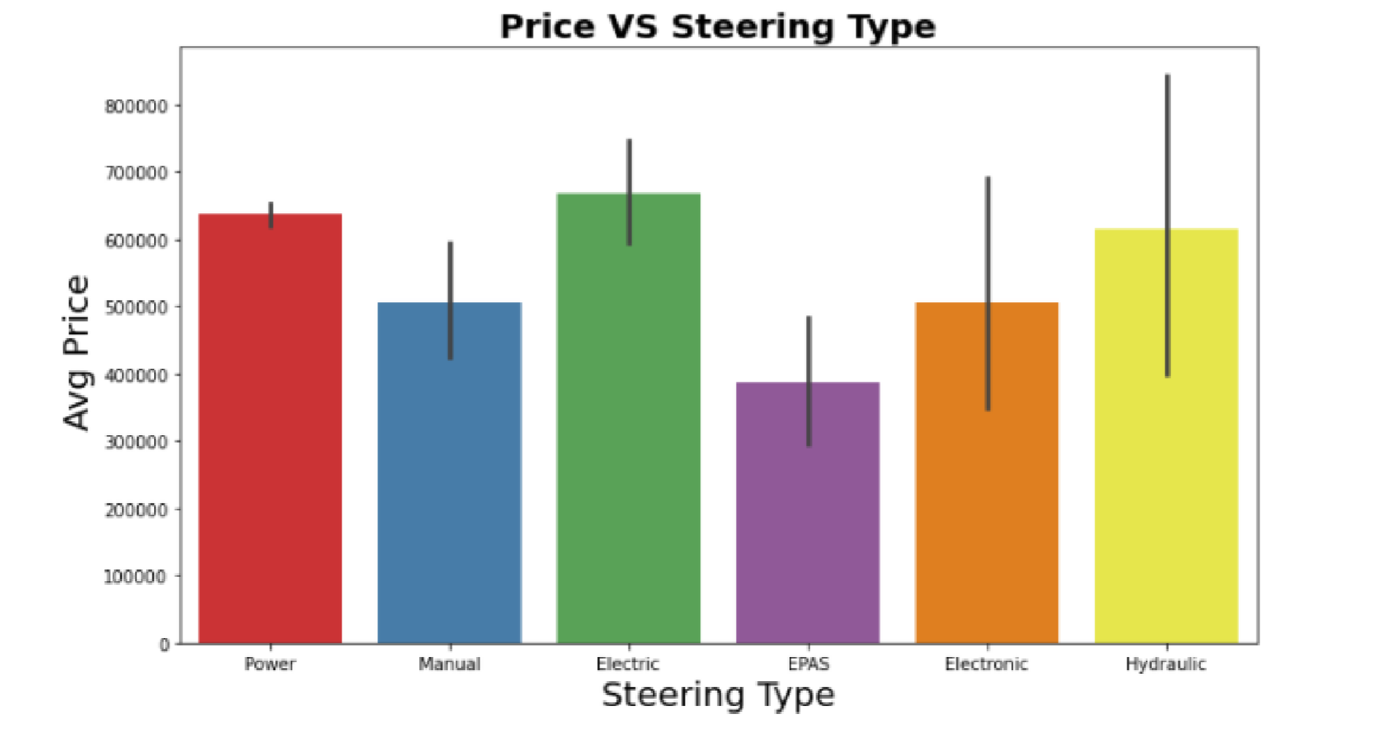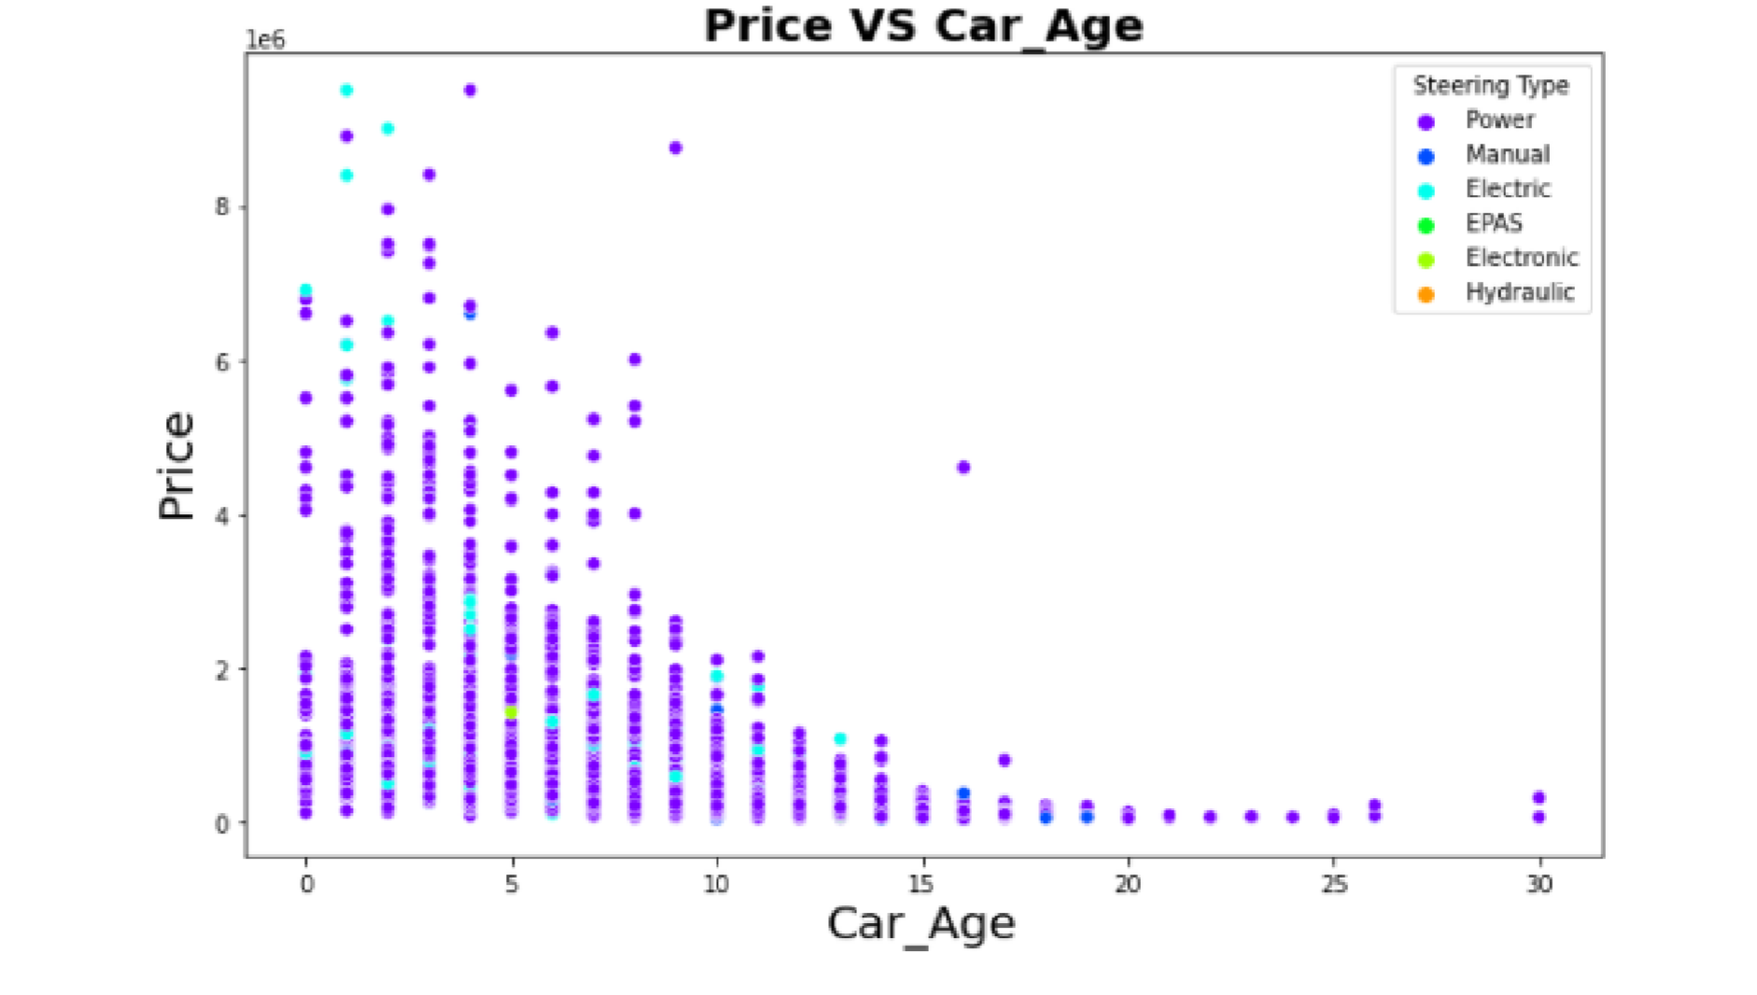

Observation:

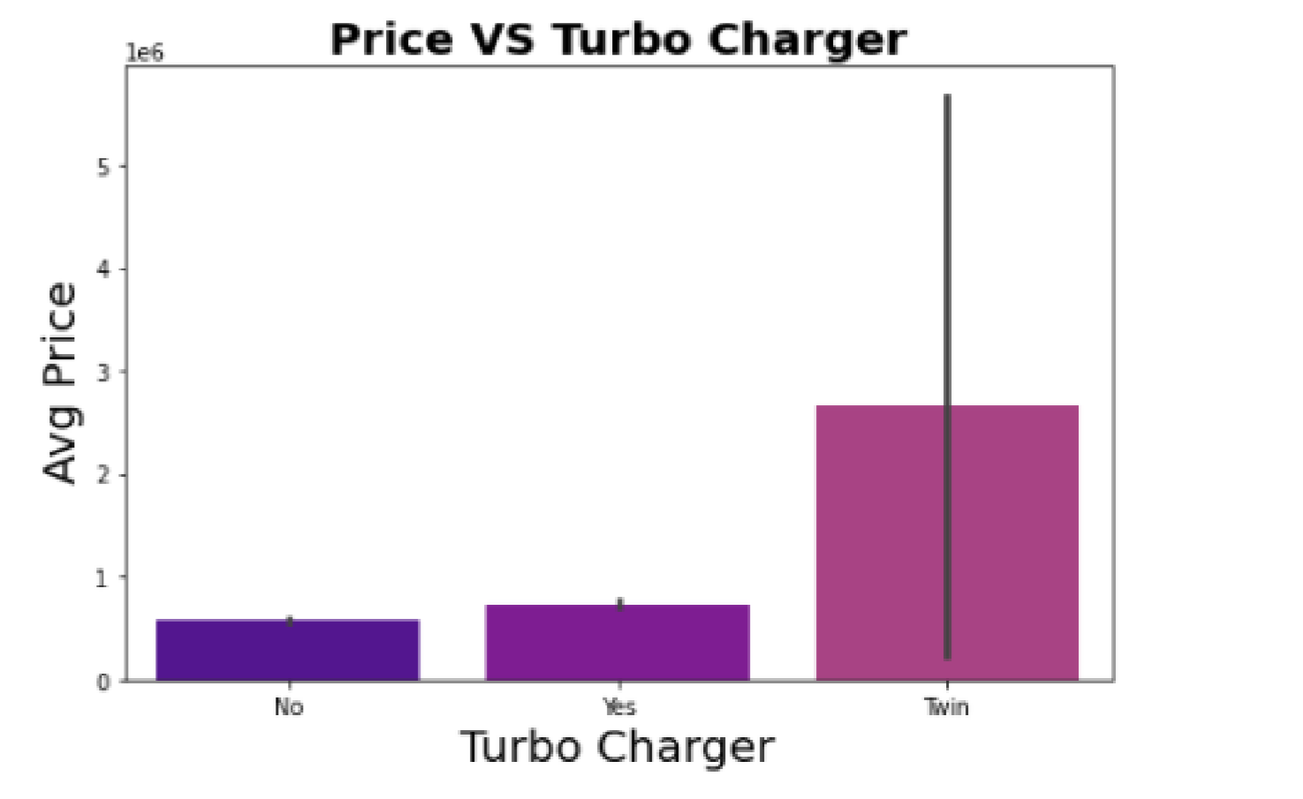

* 6.2% car based on electric steering, which is costly compare to others.
* Very small section of car still uses Manual Steering, Most probably they belong to old model.

Let check predication in last point by plotting Car age Vs Price based on steering types.

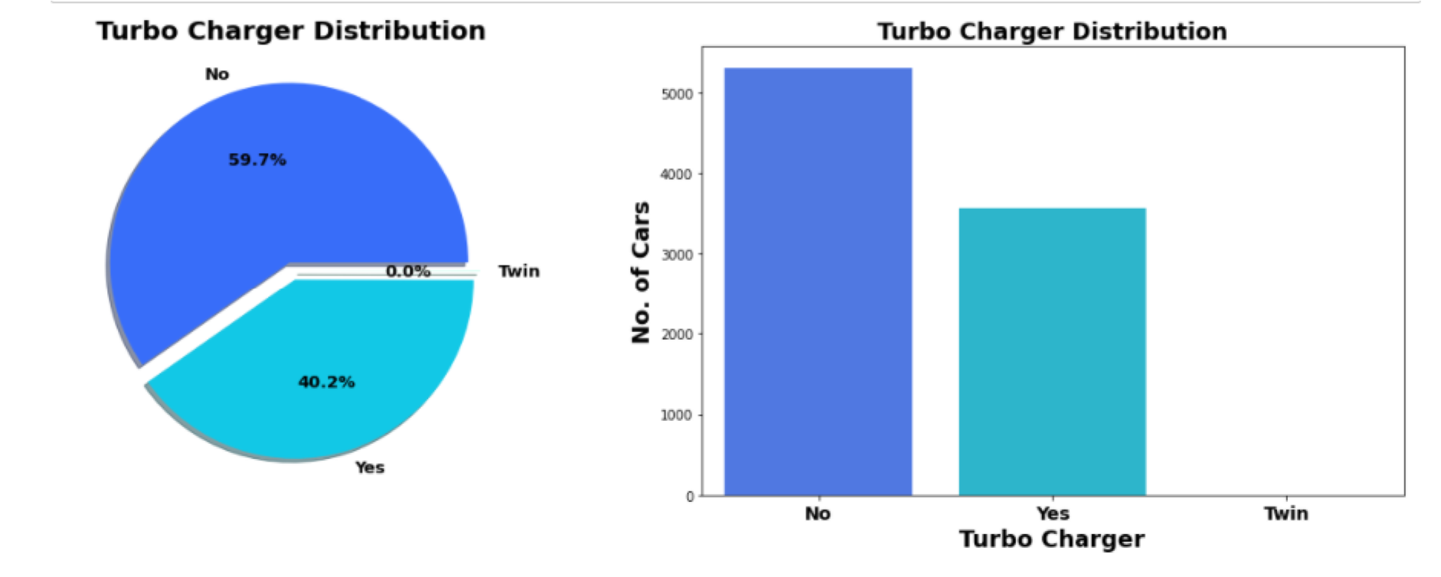

Here we got confirmation of prediction in previous section, almost all manual steering-based car at least

40% cars are with turbo charger & almost less than 1 % car with twin facility.

As expected, Max price for car based on Twin engine followed by with turbocharger.

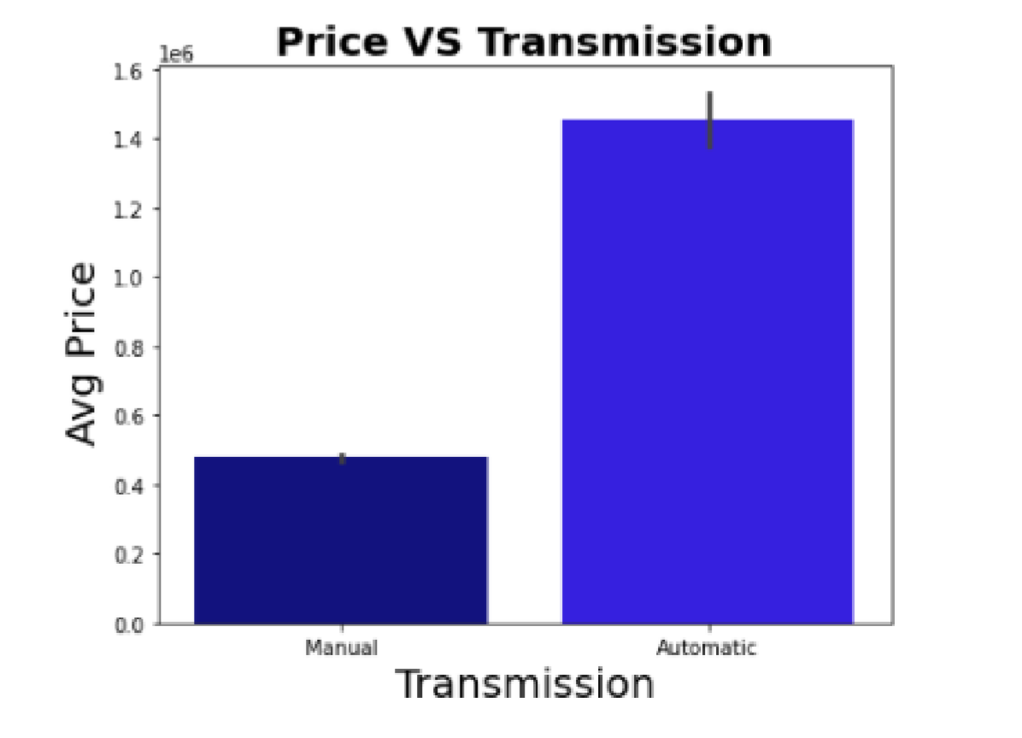

Observation:

* Most of car are with manual transmission.
* The price of Automatic transmission is much greater than manual transmission.

Let check effect of number of cylind

ers on price

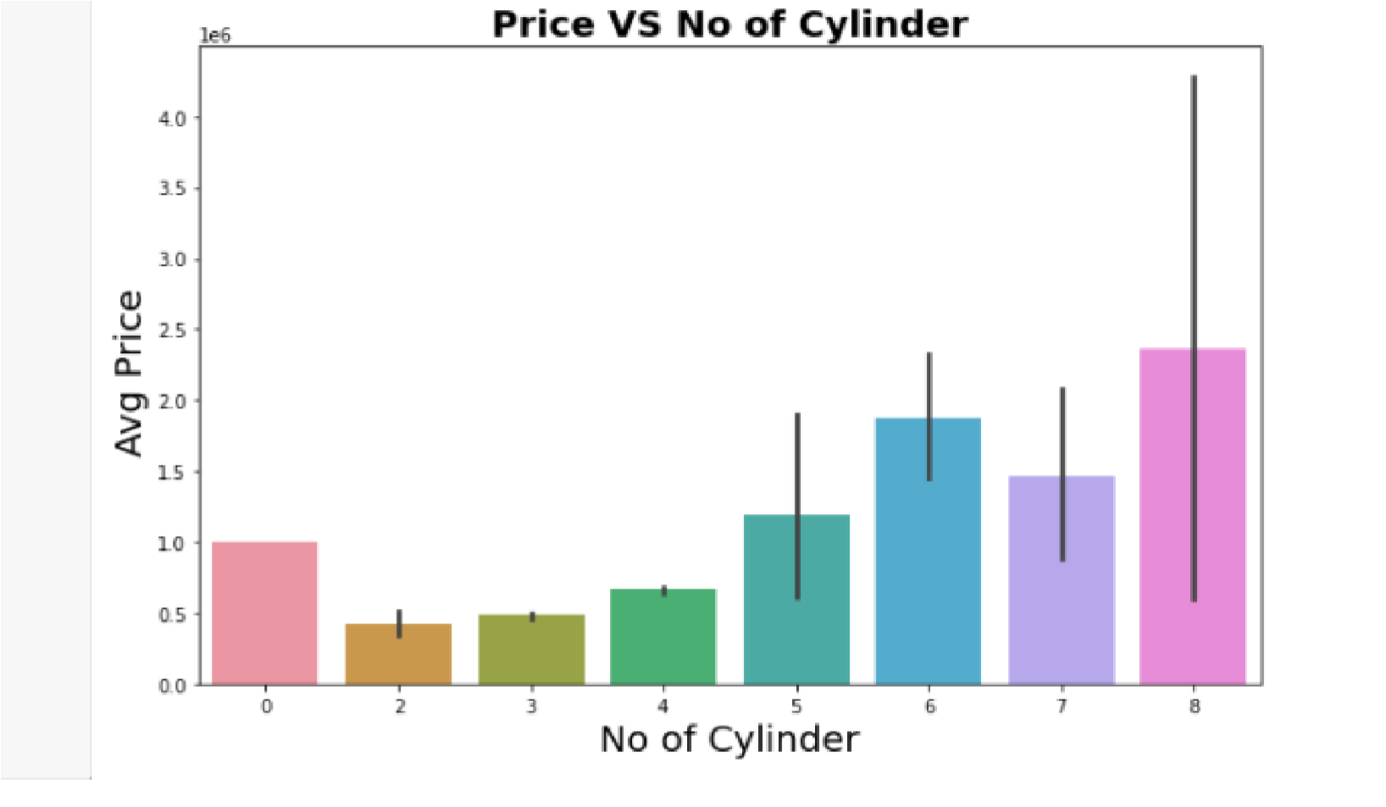

Observation:

* From value counts we got information that most of Cars with are 4cylinder engines followed by 3-cylinder engines.
* In terms of Avg. Price as number of cylinders increases the average price increases.

We know that as car price decrease as car model become older. Let’s plot bar plot of Price vs Car age to verify it.

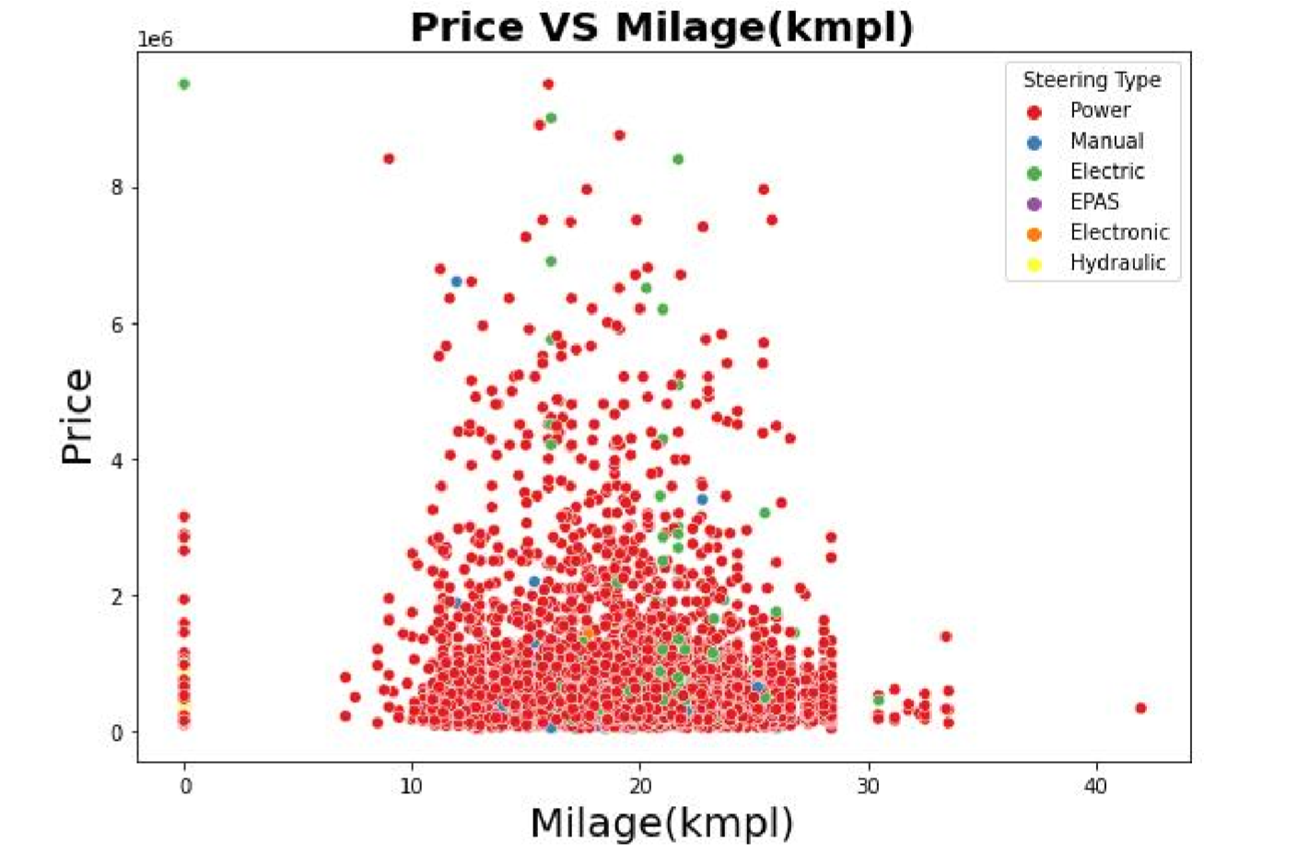

Milage (kmpl) varies in between 10 to 25 kmpl for most of cars. For Majority cars price is below 0.5e6. We didn't get any other significant relation between price and steering types.

As car get older, price of car deprecates.

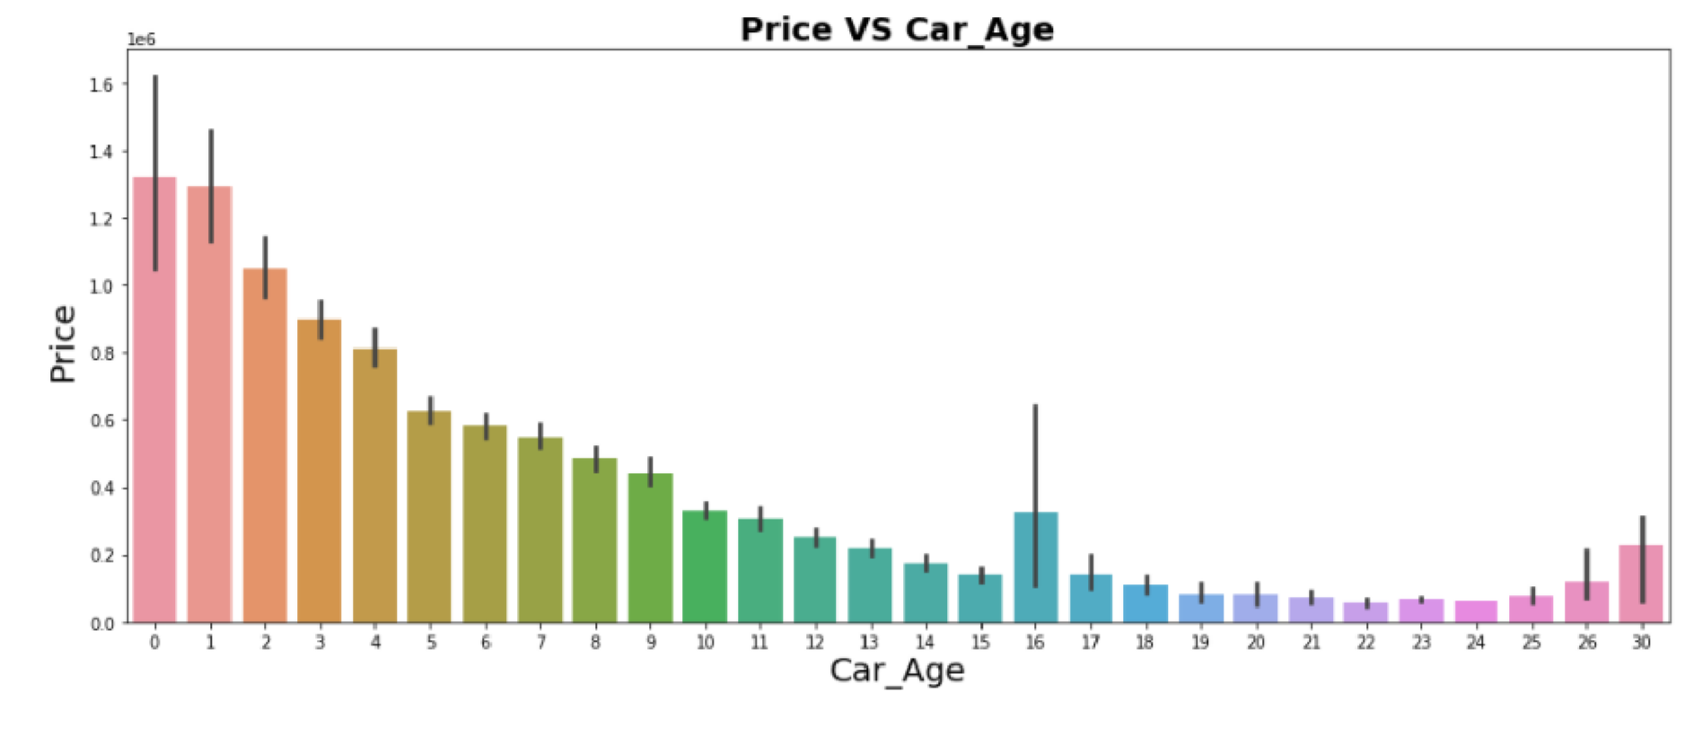

### 6. Interpretation of the Results

* As car model get old eventually its price reduces with time.
* In terms of Avg. Price as number of cylinders increases the average price increases.
* The price of Automatic transmission is much greater than manual transmission.
* 40% cars are with turbo charger & almost less than 1 % car with twin facility.
* Almost all manual steering-based car at least 10-year-old.
* More than 90 % of car users prefer Power steering compares to others.
* Very small segment of electric car and also price is quite high compare to petrol based.

### 1. Key Findings and Conclusions of the Study

|  |  |  |  |
| --- | --- | --- | --- |
| Algorithm | R2 Score | CV Score | R2 Score - CV  Score |
| Random Forest Regressor | 83.70 | 75.99 | 7.29 |
| Extra Tree Regressor | 80.32 | 74.97 | 12.41 |
| Decision Tree Regressor | 67.36 | 58.66 | 28.72 |
| XGB Regressor | 87.38 | 81.46 | 5.92 |

* On Basis of difference between R2 Score and Cross Validation Score XGB Regressor is selected as best model with 87.38% R2_score.
* Final Model is giving us R2 Score of 87.46% which is slightly improved compare to earlier R2 score of 87.38%.

### 2. Learning Outcomes of the Study in respect of Data Science

* Scraping data for project from www.cardheko.com. This first of such kind of project for me. Web scraping such huge amount of data challenge my scraping skill.
* Data cleaning or data pre-processing aspect of project is good hands on for me in this area. There were lot discrepancies in data scrap with different units, different names for same sub-categories. Data cleaning was big part of this project.

### 3. Limitations of this work and Scope for Future Work

* Around data for more than 10000 car scrap from cardheko.com
* We can scrap more data from different online platform like olx, car24. More data obviously means more accurate predication.
* Here we Scrap almost 24 features. But there are many different kinds of safety, comfort, entertainment features to which buyer weight while buying car. We can also include such more feature in future.